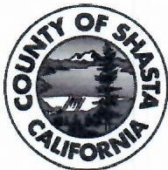
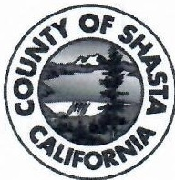
SHASI.A. COUNIY OPERATIONAL AREA I
. I EMERGENCY OPERATIONS CENTER .

PRESS RELEASE

Contact: Denis Villanueva, (530) 225-3742 or
(530) 338-4814

For Immediate Release: October 1, 2021

Local Assistance Center for Fawn Fire

Shasta County - A Local Assistance Center {LAC) will be opening to provide recovery assistance services to residents impacted by the Fawn Fire. It will be open Friday, October 8 through Monday, October 11 at the Shasta Lake Community Center, 4499 Main Street, in the City of Shasta Lake. The LAC will be open from 10 a.m. to 7 p.m. daily.

The Local Assistance Center is a one-stop-shop for recovery assistance. The purpose of the Local Assistance Center is to assist communities by providing a centralized location for services and resource referrals for unmet needs following a disaster or significant emergency. Representatives from various local, state and federal agencies will provide counseling support, resource and housing assistance, information to aid in rebuilding, permitting, hazardous materials clean-up, loss of business or employment, basic health and human services, and other topics.

Service providers will include:

- Shasta County Health & Human Services Agency
- Department of Motor Vehicles {DMV)
- California Department of Insurance (COI )
- Contractors State License Board (CSLB)
- Employment Development Department (EDD)
- California Department of Public Health - Vital Records (CDPH)
- Franchise Tax Board {FTB)
- Various private non-profit s

What documents should I bring to the Local Assistance Center (LAC)?

If you have, it is recommended that you bring:
- a photo ID,
- household income information
- insurance documents. *OMV is also available to issue duplicates of Photo IDs and driver license.

Also, California Employment Development Department (EDD), provides temporary unemployment benefits to people whose jobs or work hours were directly impacted by the fires. Affected individuals are encouraged to apply here https:// www.edd.ca.gov/Unemployment/ UI Online.htm. Claimants can also file by phone at 1-800-300-5616 (English) or 1-800-326 -8937 (Spanish.)

